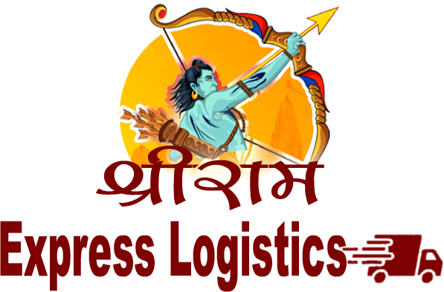
COMPANY PROFILE

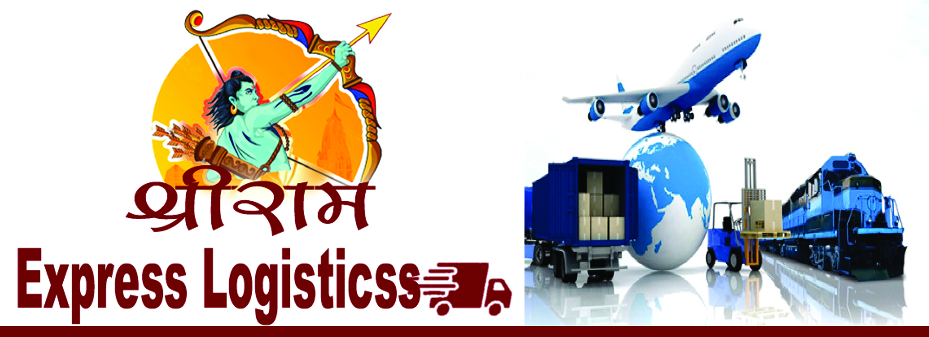

Transportation effect every part of our lives Whether, it is direct or indirect. Without transportation we have no development. It is difficult to
Imagine our world without transportation. Anyone in the world can’t live easy.

PROFILE

Shri Ram Express Logistics, was established in 2015 by Seema Singh with more than
5 years of experience of the Logistics Industry and passionate belief of transforming lives through transportation.

Our Regd. office and branches are equipped with well-qualified and experienced staff to provide best and round the clock services. We provide our clients Express Service (If required) with nominal charges to ensure quick and timely delivery.

Shri Ram Express Logistics, is committed to serve the customers by offering complete
transportation services to our customers. We have computerized monitoring system to
keep track of the fleet to ensure increased efficiency and timely delivery of your goods, our Business philosophy revolves around the customer dedication, innovation and value creation.

We are passionate about operating to the highest possible standards and we are committed to exceeding our customers’ expectations. We have established a reputation of trust and goodwill among our clients and have gained recognition as a leader in the logistics market.

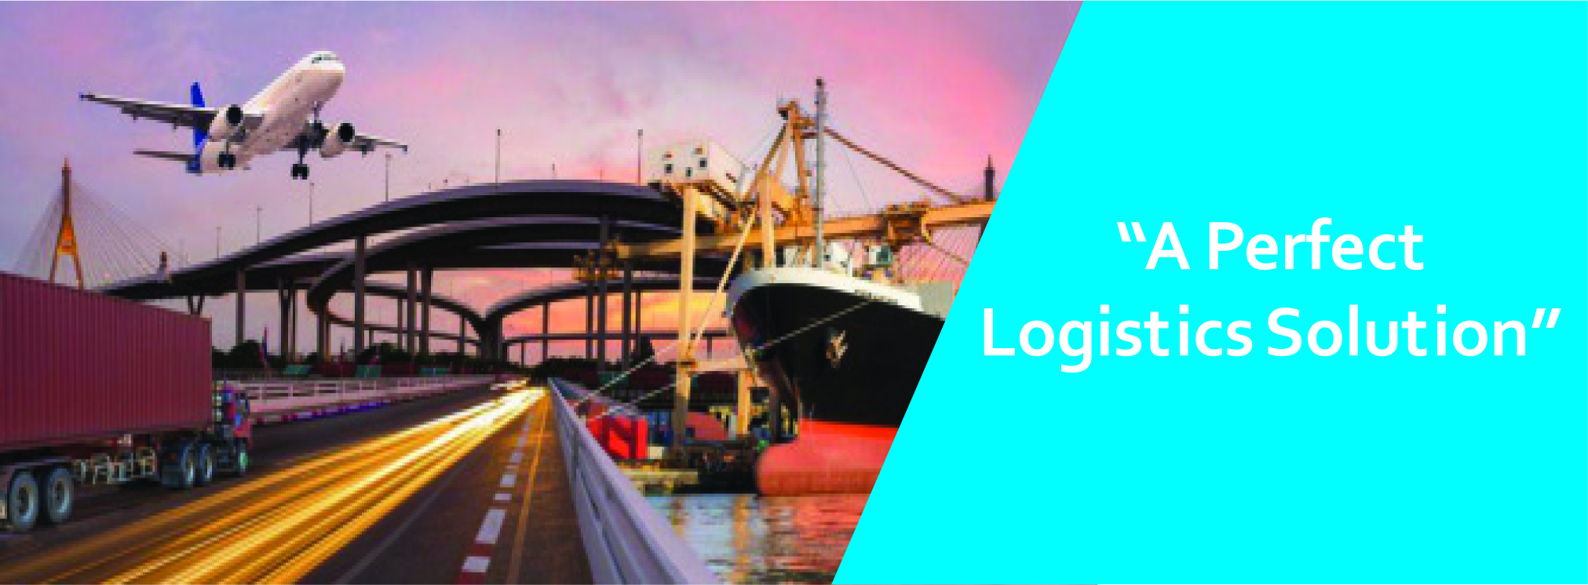

SERVICE

Shri Ram Express Logistics has large fleet of vehicles to ensure safe delivery. We operate through our Regional offices across India; we provide affordable prices & excellent service round the clock. We coordinate with you to give you a hassle free experience. We develop affordable logistics plans for transport your valuable goods.

SILENT FEATURE

⇒ Time bound Delivery

⇒ Specialized in delivery in rural areas

⇒ Containerized transportation for fragile cargo

⇒ Full Load Vehicles available for any weight

⇒ Frequent tracking alert if required through mail or sms.

INBOUND TRAFIC (DOOR TO DOOR DELIVERY)

As freight forwarders Lakshya can provide door to door service with its worldwide network. From the time an order is placed with vendors; Lakshya can monitor and coordinate the movement of cargo. Its door to door services is comprehensive and takes into account every cost factor.

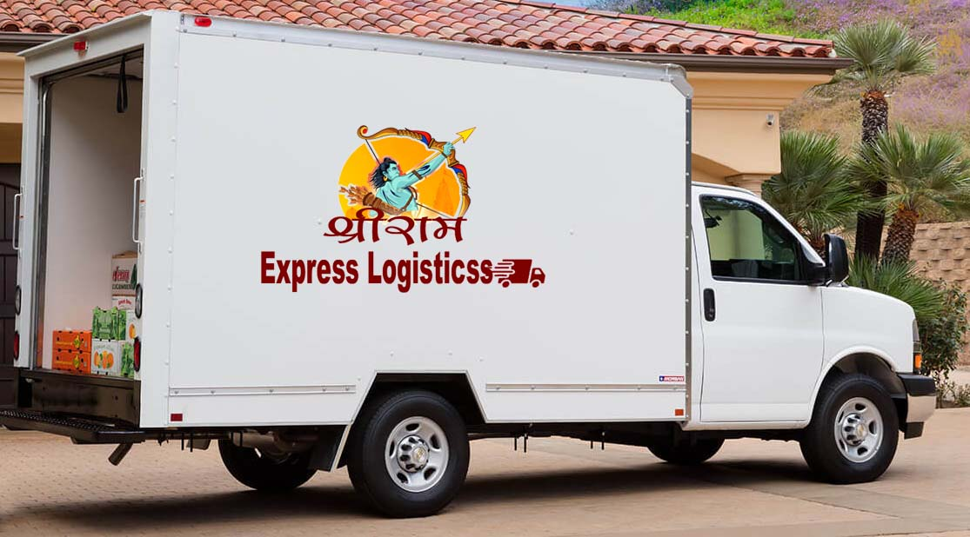

The company has purely got its own transportation and is also a fleet owner with overheads like trucks, pickups, tempos, etc. Also other transportation equipment and manpower of high-calibre like trackers to locate the exact location of the vehicles. Also the group has tie-ups with almost 50 vehicles, which helps us to cut off the bad phase of the market of ups and downs. The company is specialist in Bihar and Jharkhand route. This division has its independent staffs and customer care unit; complete in terms of Manpower and technical knowledge for looking after daily transaction and reducing the unwanted transportation which benefits to our valued customers.

⇒ Large fleet owned vehicles: 15 Vehicles.

⇒ Effective Communication network Fixed Lines, Mobiles to all the branch heads and operations supervisors, specialized customer care team.

⇒ Undertaking larger projects on turnkey basis.

⇒ Specialized in door to door movements.

⇒ Loading/unloading with help of cranes and forklifts.

⇒ Movements by Road and Air

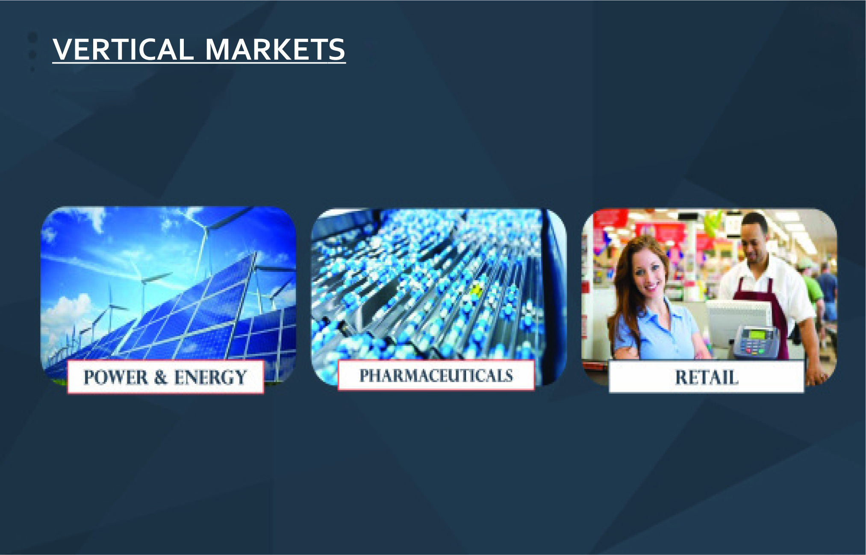

OUR PRESTIGIOUS CLIENTS

Like you, we are aiming for success. Your success defines our own success. We enjoy a successful working partnership with a number of high profile businesses and organizations, which draw upon our expertise in a variety of areas pertaining to logistics, supply chain management and value added services. We appreciate the trust our clients have put in us and we in turn are proud to be associated with them. Here are some of them:

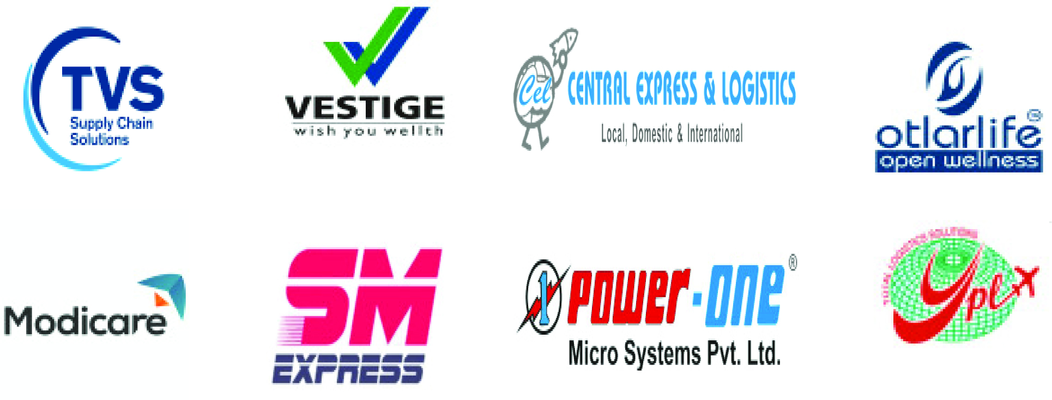

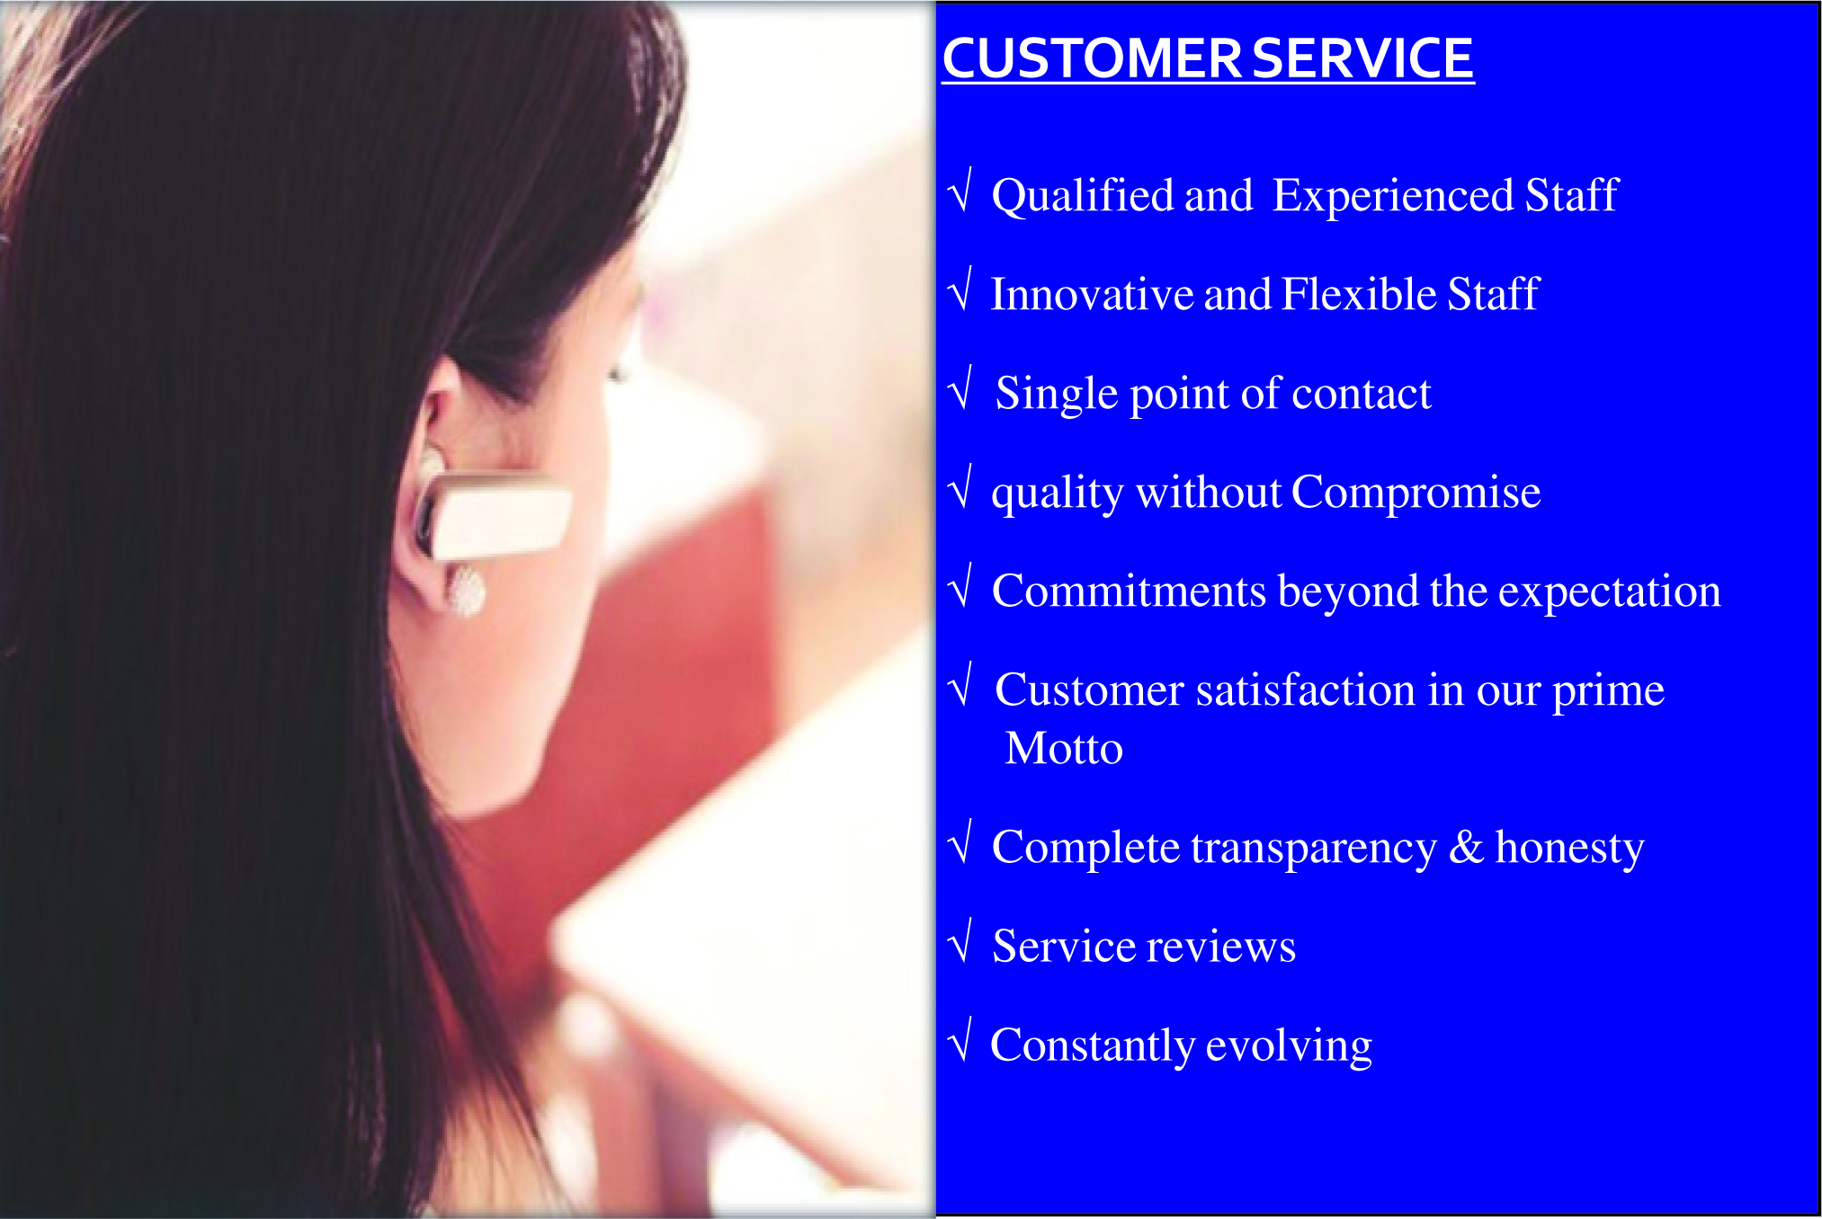



Head Office:

Below Hotel Sukhdev Palace, Bigrahpur
New bypass road, Patna, Bihar 800001
Ph: 9304820575,
email:- info@shriramexpresslogistics.com, santoshcel@gmail.com
website:- www.shriramexpresslogistics.com

Branch Office:

Near Preamsons Workshop 2
Namkum Industrial Area Samlong
Ranchi, Jharkhand 834010
Ph: 9304820575



